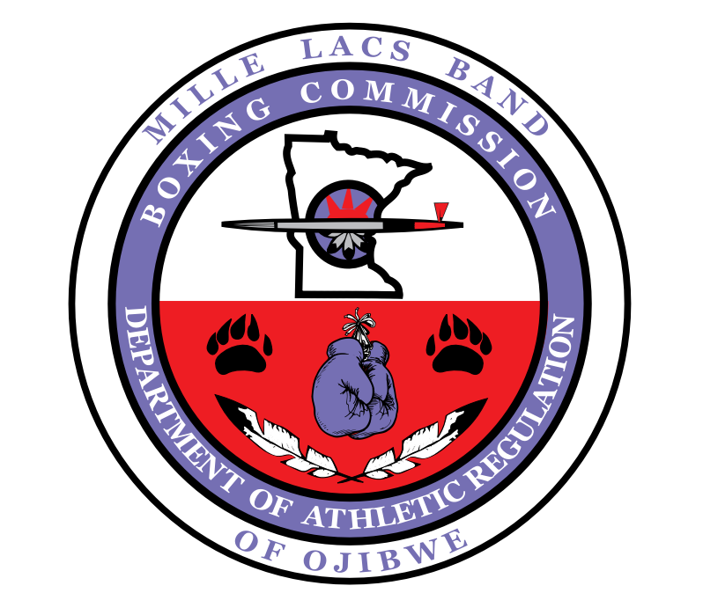
Mille Lacs Band of Ojibwe
Department of Athletic Regulation

COVID-19
Operational Procedures

August, 2020
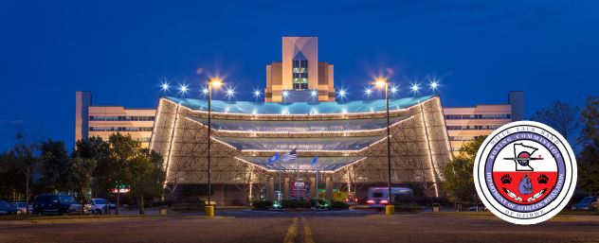

GENERAL:
The Mille Lacs Band of Ojibwe – Department of Athletic Regulation (MLBO DAR, DAR, Commission) has developed the following policies and procedures to ensure the general safety and welfare of everyone involved in the production of a live or televised combative sporting event during the COVID-19 pandemic era, within the jurisdiction of The Non-Removable Mille Lacs Band of Ojibwe. This includes “closed set” events in which the commission will regulate an event without spectators and as few production, operational and regulatory staff as possible.

PURPOSE:
The purpose of this document is to establish uniform health and safety protocols for combative sporting events held within the jurisdiction of the MLBO DAR. These protocols are to be implemented, as approved by the commission, in addition to standard rules, policies and procedures of the Commission. All personnel must adhere to the following policies, at all times or risk forfeiture of stipend. Any deviation from the approved procedures must be approved by the MLBO DAR Executive Director and Commissioners.

This document shall not supersede the health, safety and general welfare guidance provided by the Mille Lacs Band of Ojibwe – Health and Human Services or The State of Minnesota. The MLBO DAR may amend this document or require additional protocols not established herein.

EXECUTIVE SUMMARY:
Athletic competition has been a part of our history and culture since time immemorial. In modern times, combative sports provide jobs for athletes, promoters, hospitality workers, media and especially Mille Lacs Band Members. In order for combative sports to safely resume under the jurisdiction of The Mille Lacs Band of Ojibwe, it is crucial for a robust COVID-19 testing plan to be initiated. An effective regulatory program will need to encompass viral detection and mitigation. All individuals, regardless of function will need participate in a testing and possible quarantine program in line with the recommendations of the Mille Lacs Band of Ojibwe – Health and Human Services. There are no mechanisms that will ensure the competition is “100% free” from COVID-19 infection but by strict adherence to the following policies and procedures we can significantly mitigate the chance of COVID-19 infection in combative sports regulated by the DAR.

CLOSED SET:
At this time, all combative sporting events shall be limited to those essential for a safe and fair contest. Public spectators and non-essential personnel are prohibited from entering the venue or those areas identified by the Commission as restricted access areas.

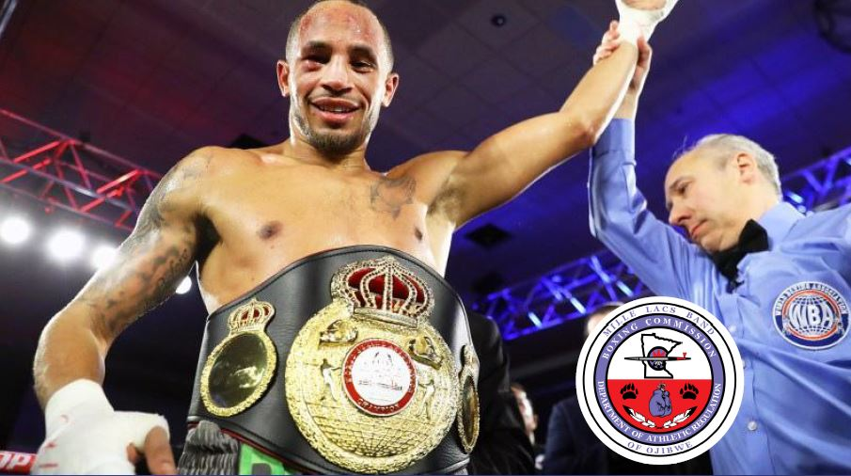

COMMISSION REQUIREMENTS:
The Commission shall require every Promoter licensed by the DAR to submit to the Commission for review, consideration and approval an operational plan which adheres to the following:

- Recommended physical distancing guidelines of a minimum of 6 (six) feet for all event personnel. When distancing is not feasible (such as between DAR Staff, Second, Referee and/or Medical Personnel) other measures including face covering, hand hygiene, cough etiquette, overall cleanliness and sanitation shall be employed.

- Protective / preventative measures and equipment. All non-DAR Staff will be supplied with gloves, masks (N95 or equivalent) and hand sanitizer. Disinfectant wipes, disinfectant spray and “bio bags” for discarded PPE will be made available to all event personnel.

- Testing and daily screening procedures. Must include COVID-19 antigen testing procedure, temperature screening and health history questionnaires to be given to all athletes and staff participating in the event.

- Isolation Procedures - including a list of all contestants with the name of the host hotel and the method of transportation to and from the venue.

- Positive Test Procedures – An Isolation plan for any non-local athlete or team member that tests positive. This includes denial of access to and from venue. Refusal to test will result in a presumed positive test.

- Cleaning Procedures – The Boxing Ring / MMA Cage and Technical Area will be cleaned with an electro-static disinfection using a disinfectant solution approved by The US Environmental Protection Agency (EPA) and The US Centers for Disease Control and Prevention (CDC). The host hotel, casino and/or promoter will follow social distancing guidelines and practice proper preparation and protection for any food provided to the guests.

- Staffing Requirements – The DAR and Promoter will develop a comprehensive list of ALL staff that will be granted access to the venue, including venue staff. This will include the complete name, phone number and address. Those staying in a hotel shall include room numbers.

- Weigh-in and Walk Out Procedures – One contestant and two seconds will be allowed in the weigh-in room. No family members, girlfriend or unapproved media. Should physical distancing be an issue, the next combatant will enter after the first departs. The event walk-out will depend on the venue.

- Floor plans and schematics – Identify areas for training, approved food or drinks, COVID-19 antigen testing area (if applicable) at host hotel or weigh-in. Post testing quarantine area will be required until official results are received. Boxing Ring or MMA Cage must include seating for officials and medical staff within the Technical Zone, dressing area for fighters and seconds, media area, emergency medical services area and a well lit, disinfected suture area as well as location of security personnel.

- Locker Room Assignments and Cleaning Procedures – Locker Rooms or Dressing Rooms will be cleaned and disinfected after each use.

- Post Event follow-up – Fourteen (14) days after the event, the promoter will send a Health History Questionnaire to contestants, seconds and staff to ensure that no new infections or symptoms have developed. The promoter will notify MLBO DAR of any persons developing new symptoms post event.

No person shall be granted access to the venue, including event-related areas identified as Restricted Access by the Commission without a verified negative COVID-19 test result. Individuals tested for COVID-19 are encouraged to adhere to strict physical distancing guidelines, when possible, while ensuring the use of personal protective equipment in shared / common / public spaces until departure from event.

- Any person traveling to The Mille Lacs Band of Ojibwe Reservation for an event shall provide a negative COVID-19 test to the Department of Athletic Regulation prior to departure from their home location and again upon arrival at the host hotel.
- Persons residing within the boundaries of The Mille Lacs Band of Ojibwe Reservation receiving access to the event or event-related areas shall receive a COVID-19 test within 72 hours of the event with a negative result before admittance to the venue.

The Commission may use wristbands or other acceptable means to identify individuals granted access to restricted-access areas; any person removing, damaging, sharing or by other means tampering with such mechanism shall be denied entry and may be subject to disciplinary action by the Commission.

The Commission shall limit each athlete to two (2) cornermen / seconds for all unarmed combat sporting events with the exception of a world title bout in which case the athlete is allowed three (3) cornermen / seconds. Athletes are discouraged from sharing the same cornermen / seconds.

The Commission shall ensure that following personal protective equipment (PPE) is readily available for all commission staff and officials. DAR Staff will receive Gloves, masks, disinfectants and other sanitary supplies from the Commission. The Commission shall also ensure disposable surgical gowns and eye protection are available for medical staff tasked with COVID-19 specimen collection.

- All DAR Staff and Officials shall properly utilize the provided PPE at all times, including in the ring or cage.

The Commission shall require documented daily temperature checks for all event related personnel starting 72 hours in advance of the event, or upon arrival to the host hotel.

Any person exhibiting symptoms or testing positive by approved means for COVID-19 shall be disqualified from competition and/or removed from the area for quarantine or directed by a physician to the nearest emergency room. The DAR shall notify the Mille Lacs Band of Ojibwe – Health and Human Services of any person testing positive, including positive serology results.

- Athletes testing positive for COVID-19 shall be indefinitely medically suspended in the Boxing registry or Mixed Martial Arts database until cleared by a physician and proof of clearance is received by MLBO DAR. The commission overseeing the athlete’s home state will also be notified of the positive test and suspension.

Any MLBO DAR licensee engaged in reckless behavior, including: failing to abide by these protocols; intentionally spreading bodily fluids; providing false responses to medical questions; or other unacceptable behaviors may be denied access to the venue, event-related areas and may be disciplined by the commission, including fines and/or denial or revocation of a MLBO DAR issued license.

The commission shall issue a copy of the COVID-19 information sheet produced by the US Center for Disease Control (CDC) to all event related personnel.

The Commission will follow-up with all DAR staff fourteen (14) days post-event to inquire of any new symptoms developing after the conclusion of the event.

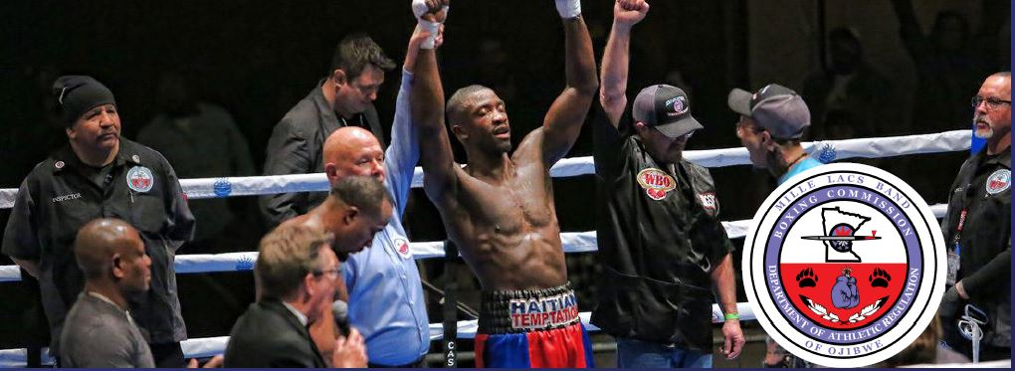

PROMOTER REQUIREMENTS:
The promotion shall be responsible for ensuring adherence to these protocols, as well as the financial costs associated with ensuring all personnel are tested in accordingly. This includes the costs associated with PPE equipment, cleaning supplies, specimen collection, shipping, testing and reporting.

The Promotion shall provide the following PPE to all non-Commission personnel: gloves, masks, disinfectants and other necessary cleaning supplies.

The Promotion shall ensure proper sterilization of the venue, host hotel and other shared areas and transportation used by event personnel.

The Promotion shall ensure that no unauthorized person (i.e. those not tested or appropriately identified) are granted access to the identified “Restricted Access” areas.

The Commission recommends that Promoters develop an isolation plan for non-local personnel testing positive for COVID-19.

The Commission recommends Promoters follow-up fourteen (14) days post-event with athletes, cornermen and staff to ensure no new symptoms have developed. The commission should be notified of any persons developing new symptoms post-event.

Laboratory:
The MLBO DAR shall require all specimens to be tested at either the Sports Medicine Research Testing Laboratory (SMRTL) or laboratories certified under Clinical Laboratory Improvement Amendments of 1988 (CLIA) or those approved by Mille Lacs Band of Ojibwe - Health and Human Services.

The Commission will require either the COVID-19 RT-PCR nasopharyngeal or saliva RNA test, provided it is approved for use by the US Food and Drug Administration (FDA).

- Promoters may elect to purchase an FDA approved or authorized COVID-19 antibody capillary or serum serology test. The use of the serology test is optional at the discretion of the Promotion, but shall not be used in-lieu of the required RT-PCR/RNA test.

PRIOR TO EVENT:
The DAR and Promotion shall create a complete list of the essential personnel that will be granted access to the venue (the list must include venue staff). The list shall include the complete name, contact phone number and city of residence for every person. Those staying at the host hotel should also include a room number.

PERSONAL PROTECTIVE EQUIPMENT:
The DAR and Promotion shall ensure every person granted access to the venue receive and correctly utilize the following:

- (1) N95 Mask (or similar mask) for each day the person will be granted access to the venue or event related areas
- (2) pairs of latex gloves for each day the person will be granted access to the venue or event related areas.
- (1) Surgical gown (or similar) with face shield, for each day and every medical personnel conducting nasopharyngeal specimen collection

All personnel must wear a facial covering, such as an N-95 mask or similar, at all times inside the venue or event related areas.

DISINFECTANT:
The DAR and Promotion shall ensure adequate disinfectant supplies are readily available at all times, ensuring common area (i.e. Cage / Ring, locker and dressing rooms, common surfaces etc.) are frequently cleaned after each use with a disinfectant solution approved by the EPA and CDC.

MEDICAL TESTING AND SCREENING:
The DAR and Promotion shall ensure every person granted access to the venue are screened and tested by the Commission medical team as follows:

- Every person shall have their temperature checked and recorded daily. The information will be reviewed by the MLBO DAR Chief Ringside Physician.
- Additional temperature checks will be performed post-event, prior to departing the arena for all combatants.
- Upon initial screening and on the day of the event, every person will be asked a series of medical questions by the DAR medical team. Any adverse answers will be followed up with additional screening.
- Upon arrival, every personal shall submit to a COVID-19 active infection test; either a RT-PCR nasopharyngeal test or a saliva RNA test is acceptable at the Promoter’s choosing, provided it is either approved or authorized by the FDA.

POSITIVE RESULTS:
Any person testing positive for an active infection, along with their staff / cornermen, will be denied access to the venue. Any person with severe COVID-19 symptoms will be directed to the nearest emergency room in accordance with MLBO DAR guidelines.

OFFICIALS:
All officials will wear gloves, masks, and eye protection when located in their working position. Eye protection can consist of a face shield, eyeglasses, or other glasses such as safety glasses or sports goggles.

SCORING:
When judges finish scoring a round, they will place the completed scorecard on the edge of the ring or in a cage loop. After the judges have backed away from the ring or cage, the referee will gather the cards and walk them to the area near the DAR staff table. The referee will place the scorecards on the edge of the ring or in a cage loop. After the referee has backed away, the DAR staff member will approach the ring or cage, retrieve the scorecards and return to the DAR staff table.

CONCLUSION OF BOUT:
At the conclusion of the bout, the DAR staff member will place the bout results at the opposite end of the table from them. Once the DAR staff member returns to their seat, the announcer may then approach the table, collect the bout result, and enter the ring. The table will be disinfected between transactions.

DECISION:
The ring announcer, contestants, and referee will remain in the ring or cage for the decision announcement. The announcer will maintain distancing of at least 6 feet from the other ring or cage occupants. After the announcement, the ring occupants will vacate the ring or cage. Contestants will stop at their respective corners to see a physician for a post-bout exam immediately after exiting the fighting area.

EXIT:
DAR staff will escort contestants and seconds to the dressing area where they will be paid, sign their contract, and collect their belongings. DAR staff will remove wristbands from the fighters and any seconds who are not working any of the following bouts. Staff will escort the contestants and seconds without wristbands to a quarantined area of the building or to an area where they can wait to be taken back to their hotel, as arranged by the promoter and approved by the lead DAR Inspector.

POST-EVENT:
The Association of Ringside Physicians recommends, when possible, athletes self-isolate for fourteen (14) days post-event, even if tests are negative, to ensure no new symptoms develop. Any person developing symptoms post-event is recommended to follow-up with their primary care physician who may consult with the Commission’s ringside physician.

This document has been prepared by the Mille Lacs Band of Ojibwe – Department of Athletic Regulation, in consultation with Dr. Gene Stringer (MLBO DAR Chief Ringside Physician), Dr. Don Muzzi (President, Ringside Physicians Association) and aligned with the recommendations of the Association of Combative Sports Commissions and World Boxing Association Medical Boards and industry “best” practices.

Health Questionnaire

EVENT NAME
EVENT DATE

Combatant Name:___________________________________________________________________________________________

Mailing Address:____________________________________________________________________________________________

Position (Circle) Combatant Second\Cornermen Ring Official
Health condition: Have you experienced any of the following symptoms in the last 14 days:
Breathing difficulty: | No | Yes
Chest pain: | No | Yes
Fever: | No | Moderate | High
Head Aches: | No | Moderate | Serious
Cough: | Mild | Moderate | Serious
Have you experienced any of the following symptoms in the last 14 days?
Sore throat | Muscle aches | Shaking/chills | Abdominal pain
Irritated eyes | Joint pains | Sweating | Irritability
Nasal congestion | Fatigue and/or weakness | Diarrhea, nausea, vomit | High blood pressure
Have you ever been diagnosed with or treated for any of the following?
Cancer | Gestational diabetes | Neurological | Pulmonary
Heart | Liver | Hematological | Kidney
Diabetes 1 or 2 | Obesity | Immune system | Immunossuppresive treatment
HIV | Other:
Epidemiological History:
Have you had contact with any respiratory disease cases in the last 14 days? | Yes No
Has any family member or close acquaintance been diagnosed with COVID-19 or is now under surveillance as a suspected case? | Yes No
Has any family member or close acquaintance had contact with someone diagnosed with COVID -19, or that might be under surveillance as a suspected case? | Yes No
Have you been tested for the detection of COVID - 19? | Yes No
Date of test | _____ / ______ / _________
Results of test | Positive Negative
After reading and completing this COVID – 19 questionnaire, I declare that to the best of my knowledge, all the information expressed herein is truthful.

SIGNATURE _______________________________________ DATE __________________

