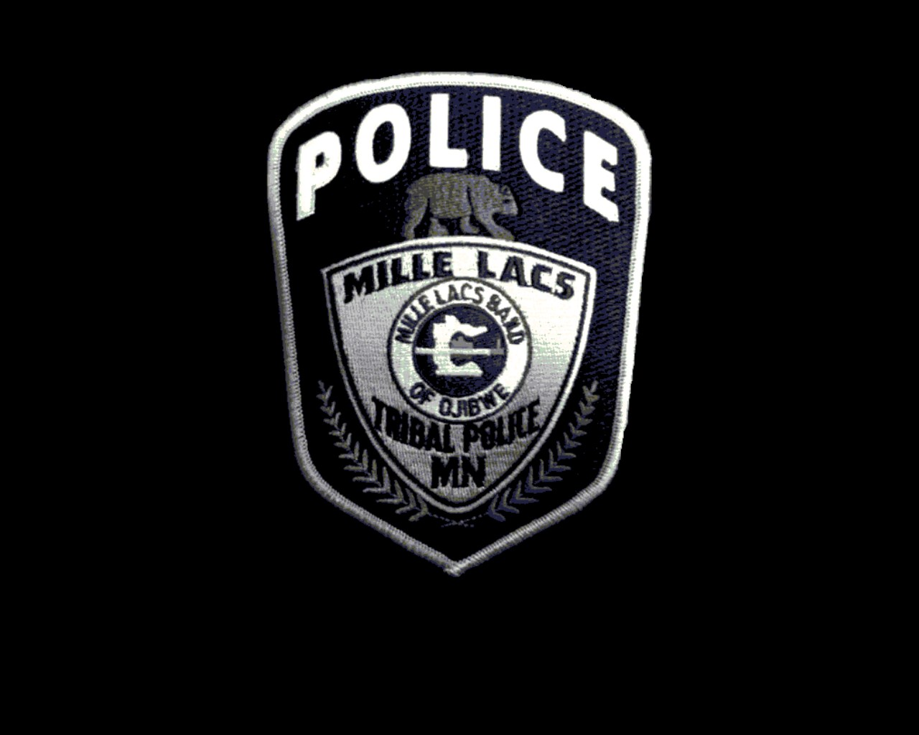
MILLE LACS TRIBAL POLOICE DEPARTMENT
43408 Oodena Drive Onamia, MN 56359
Ph. 320-532-3430 Fax 320-532-4190

REQUEST FOR SCHOOL RECORDS

Date:

Name of Applicant:

Social Security Number of Applicant:

The above named individual has applied for a position as a Police Officer with the Mille Lacs Tribal Police Department. This applicant has indicated that he or she has attended your school.

The applicant has given a valid release for all public and private data which you and your school may have created, collected or maintained about the applicant. A copy of this release is attached. This authorization shall be valid for a period of one year, but the applicant reserves the right to cancel the authorization at any time prior to that expiration by providing written notice to you or the Mille Lacs Tribal Police Department.

Please send us a copy of all documents pertaining to this student, including but not limited to; Transcripts, student disciplinary actions, achievements, and awards.

If you have any questions please feel free to contact the background investigator at:

Background Investigator
Mille Lacs Tribal Police Department
43408 Oodena Drive
Onamia, MN 56359
320-532-3430
jared.rosati@millelacsband.com

Attach a TYPE 1 Release Form

